Practical - 1
Practical Title: Project Initiation, Requirement Analysis, Sitemap, Wireframe, and GitHub Setup

Problem Definition: Initiate the semester-long StudentHub portal by identifying the problem scope, user roles, key modules, navigation flow, and minimum 10 pages. Create a sitemap, low-fidelity wireframe, project folder structure, README file, and GitHub repository.

Theory

What is URL and parts of URL?
Answer:
URL (Uniform Resource Locator) is the address of a web page or resource on the internet. It tells the browser where to find the resource.
Parts of a URL: • Protocol: https:// – Defines how data is transferred.
• Domain Name: www.example.com – Identifies the website.
• Path: /folder/ – Specifies the folder containing the resource.
• File Name: index.html – The web page being requested.

How does HTML file process in web browser?
Answer:
The user enters a URL or opens an HTML file.
The browser locates and loads the HTML file.
The browser reads the HTML code from top to bottom.
It creates the page structure (DOM).
It loads linked resources like images, CSS, and JavaScript. Finally, it renders and displays the web page on the screen.

3. How will page navigation flow managed among all HTML pages?
Answer: Page navigation is managed using the HTML <a> (anchor) tag with the href attribute. Example: <a href="about.html">About</a> Each page contains links to other pages, allowing users to move between them. For example: Home → Login → Dashboard → Courses → Profile → Contact This creates a connected website where all pages are linked together.

4. How will GitHub commits be maintained after each practical?
Answer:
After completing each practical:
1. Save all project files.
2. Stage the changes: git add .
3. Create a commit with a meaningful message: git commit -m "Completed Practical 3 - Student Login Page"
4. Push the changes to GitHub: git push origin main A separate commit is created after every practical, making it easy to track changes, view progress, and restore previous versions if needed.

Implementation/ Output/Result
Wire frames :
- Index
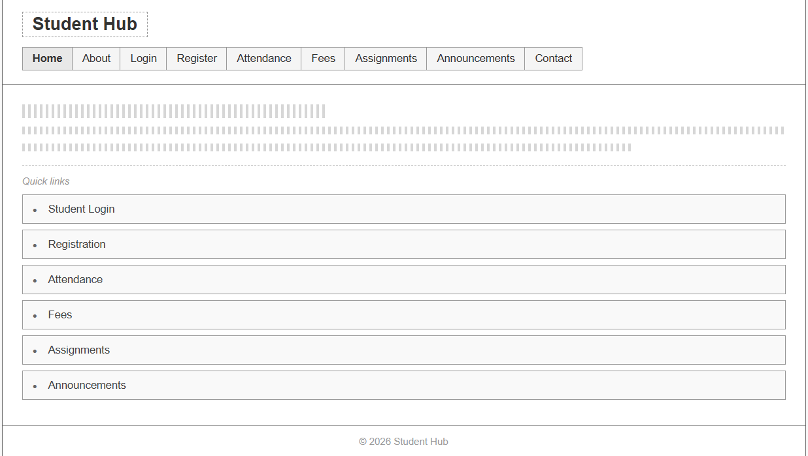

- About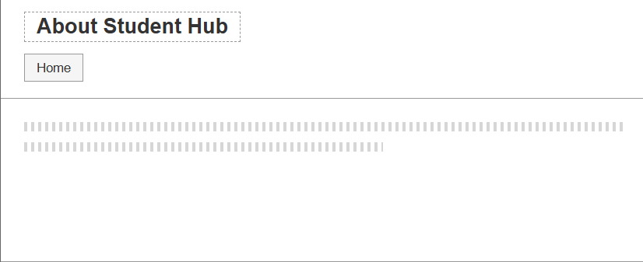
- Login
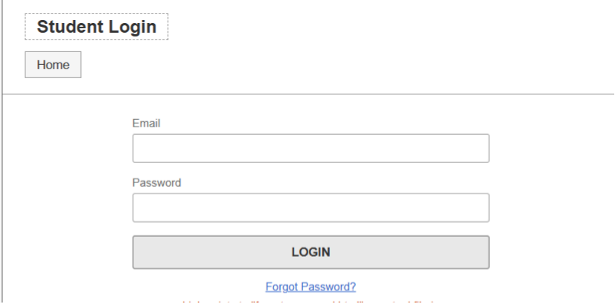
- Forget passoword
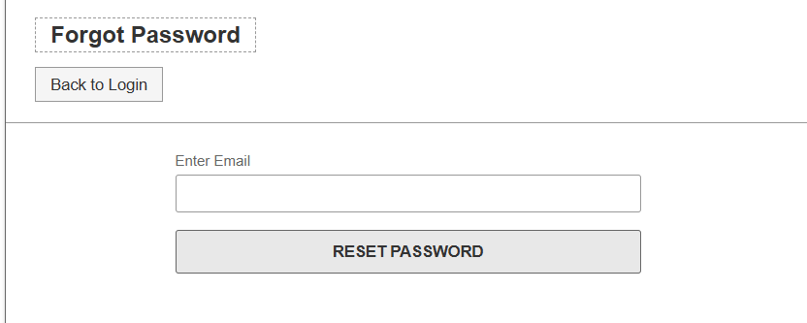

- Register
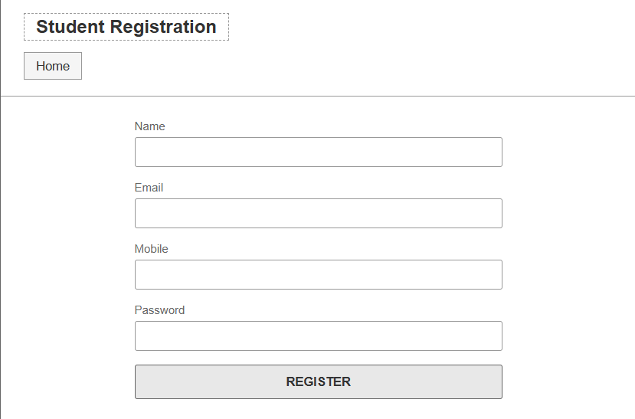

- Attendance
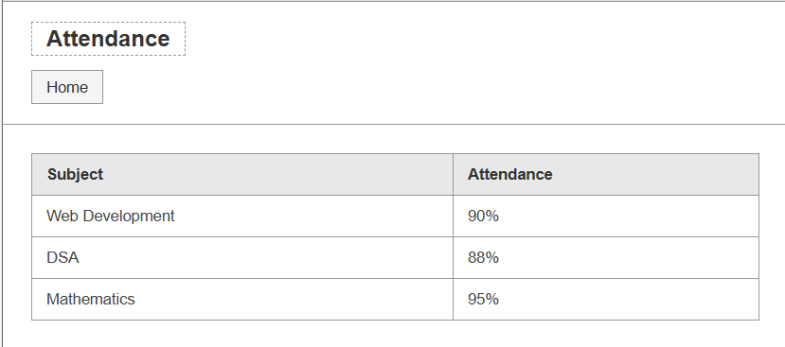
- Fees
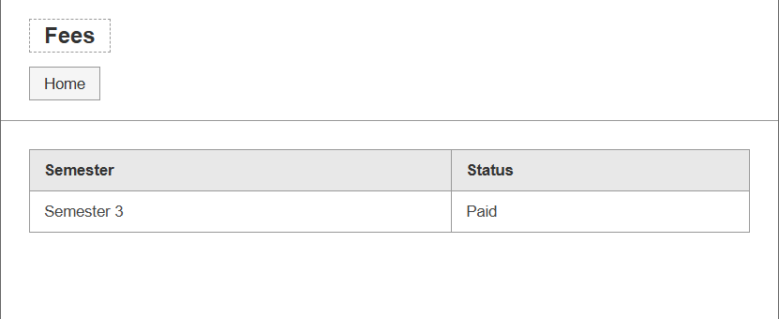

- Assignments
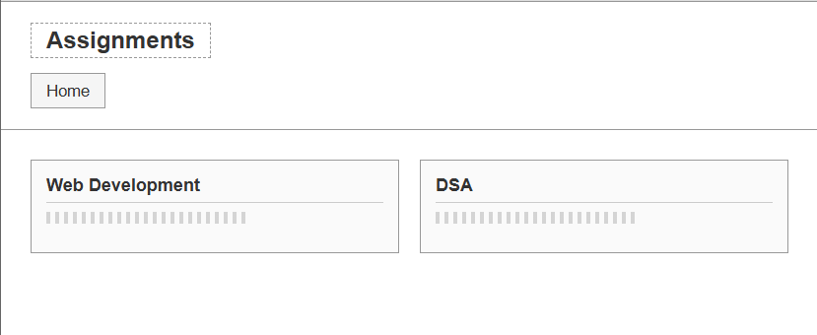

- Announcements
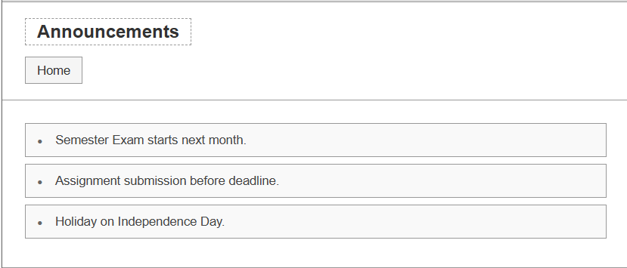

- Profile
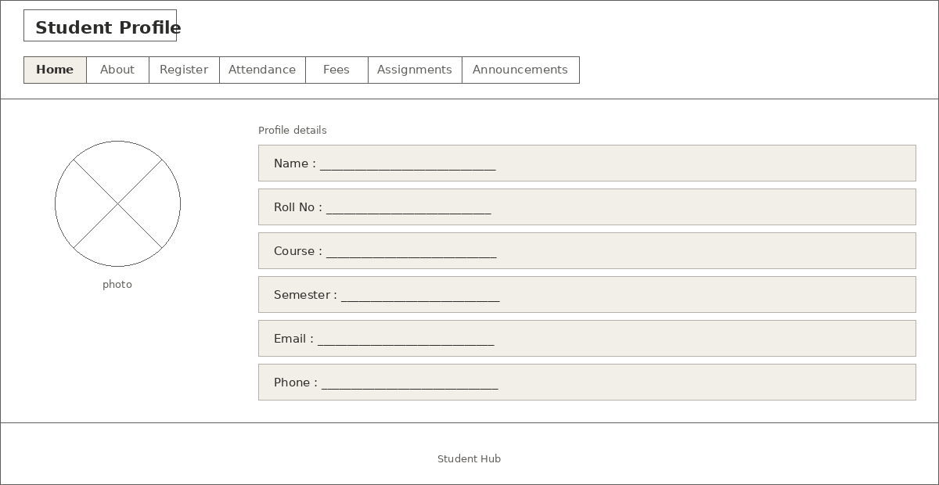

GitHub Repository Link:

https://github.com/Shreyansh2210/Web-Devlopment

Faculty Remarks:

